- INSTALL GIT
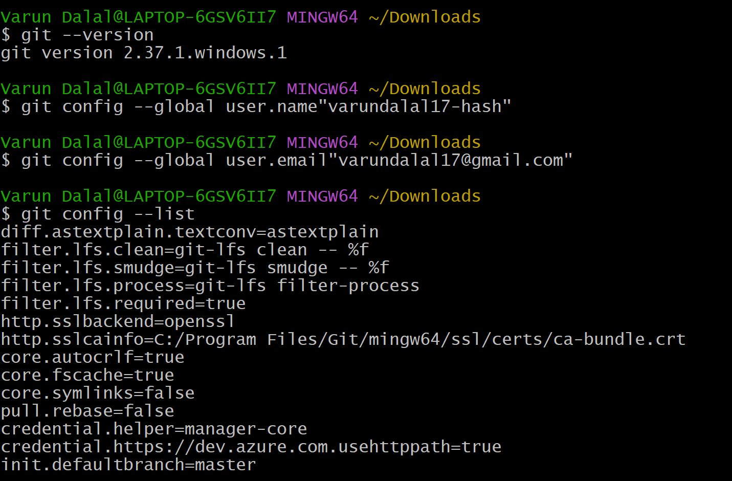

- Create a repo in git hub with README.md and . ignore file
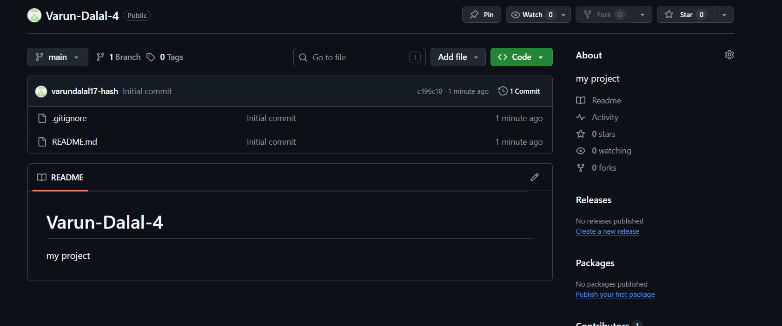

3. Clone the created repo to local
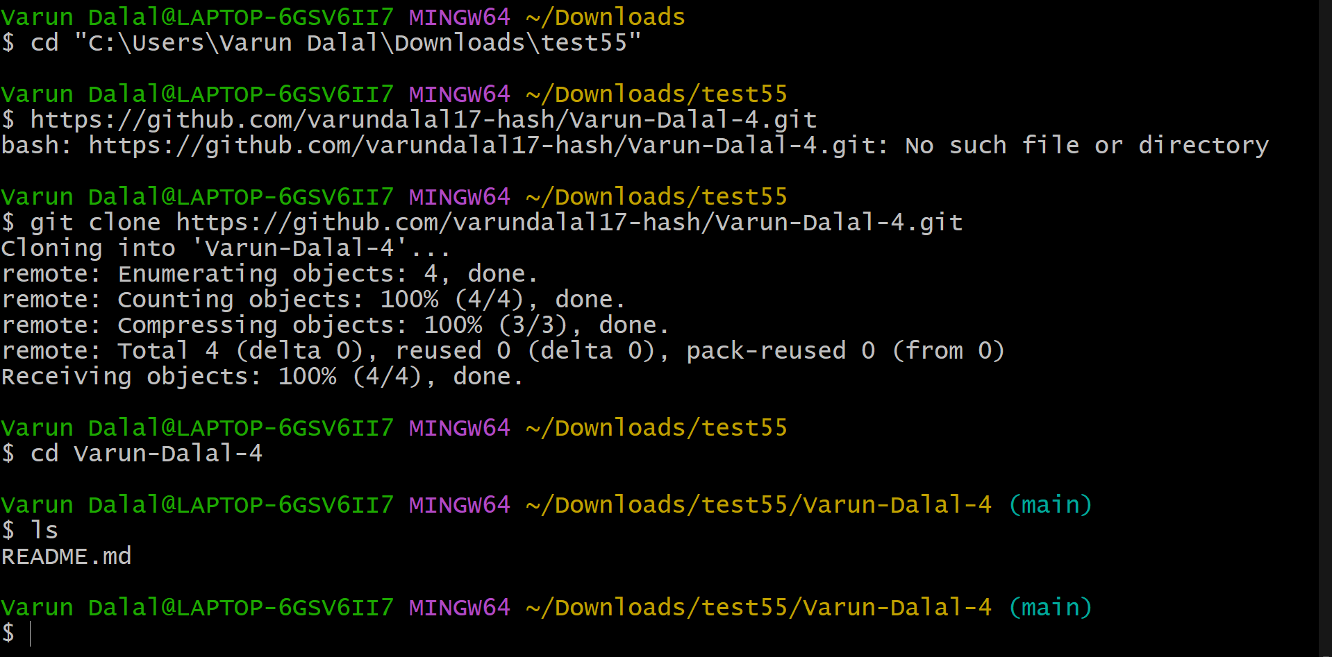

4.Create two files in local repo.
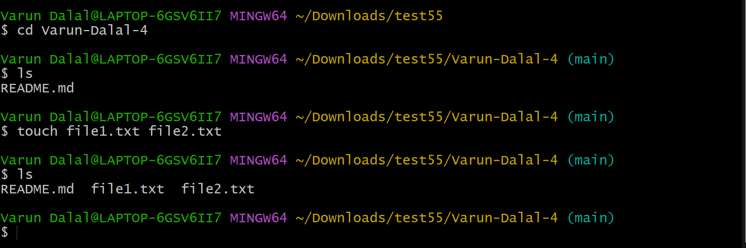

5. Commit two files and push to central Repository
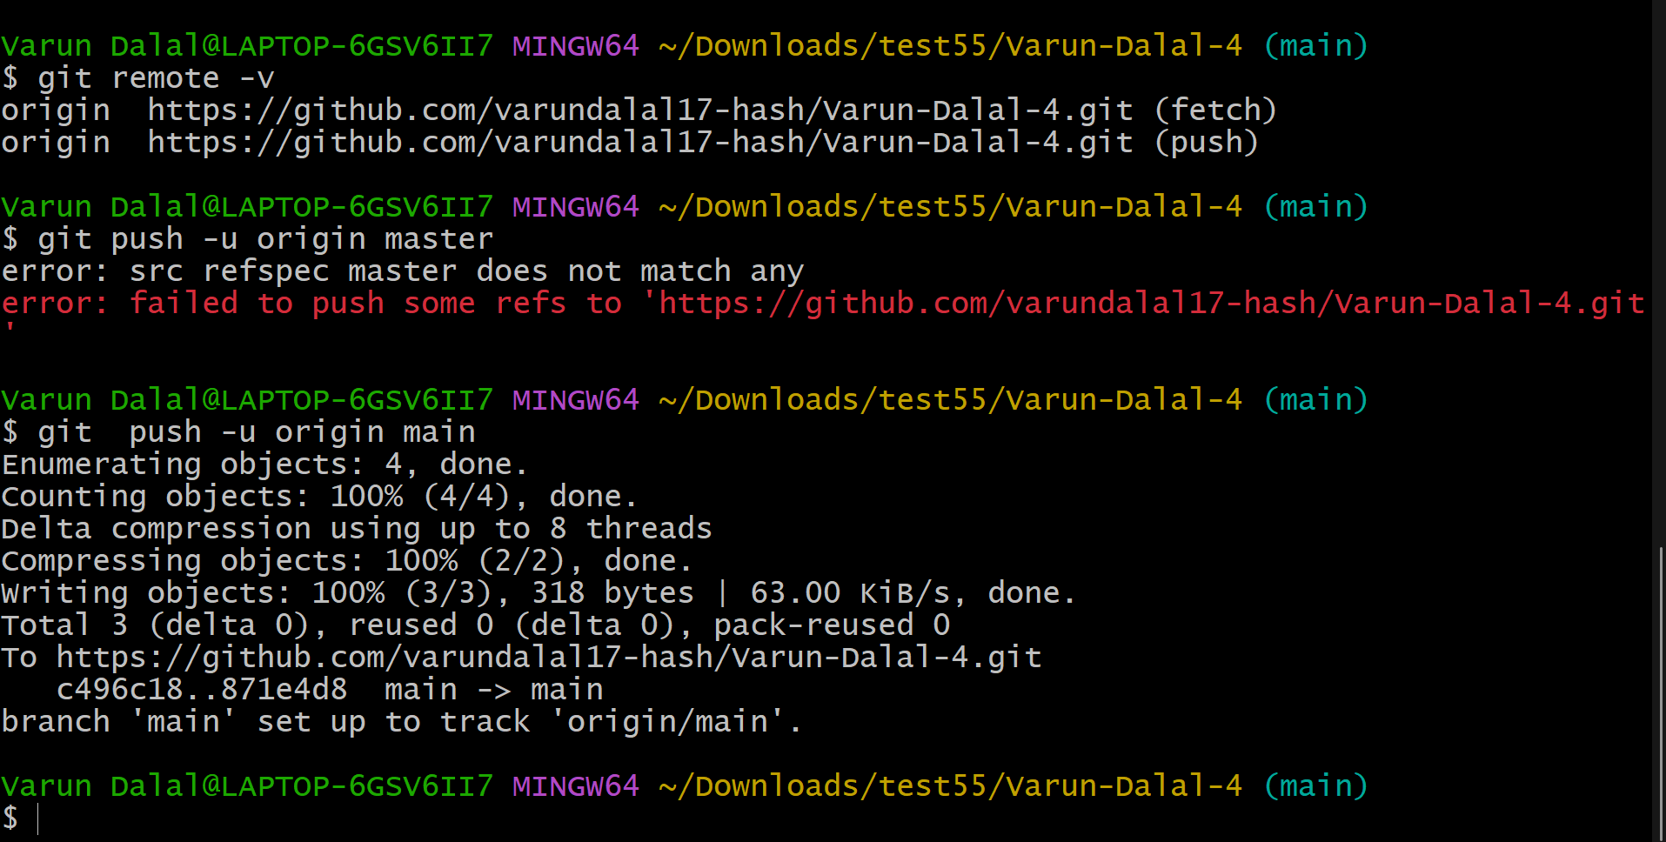
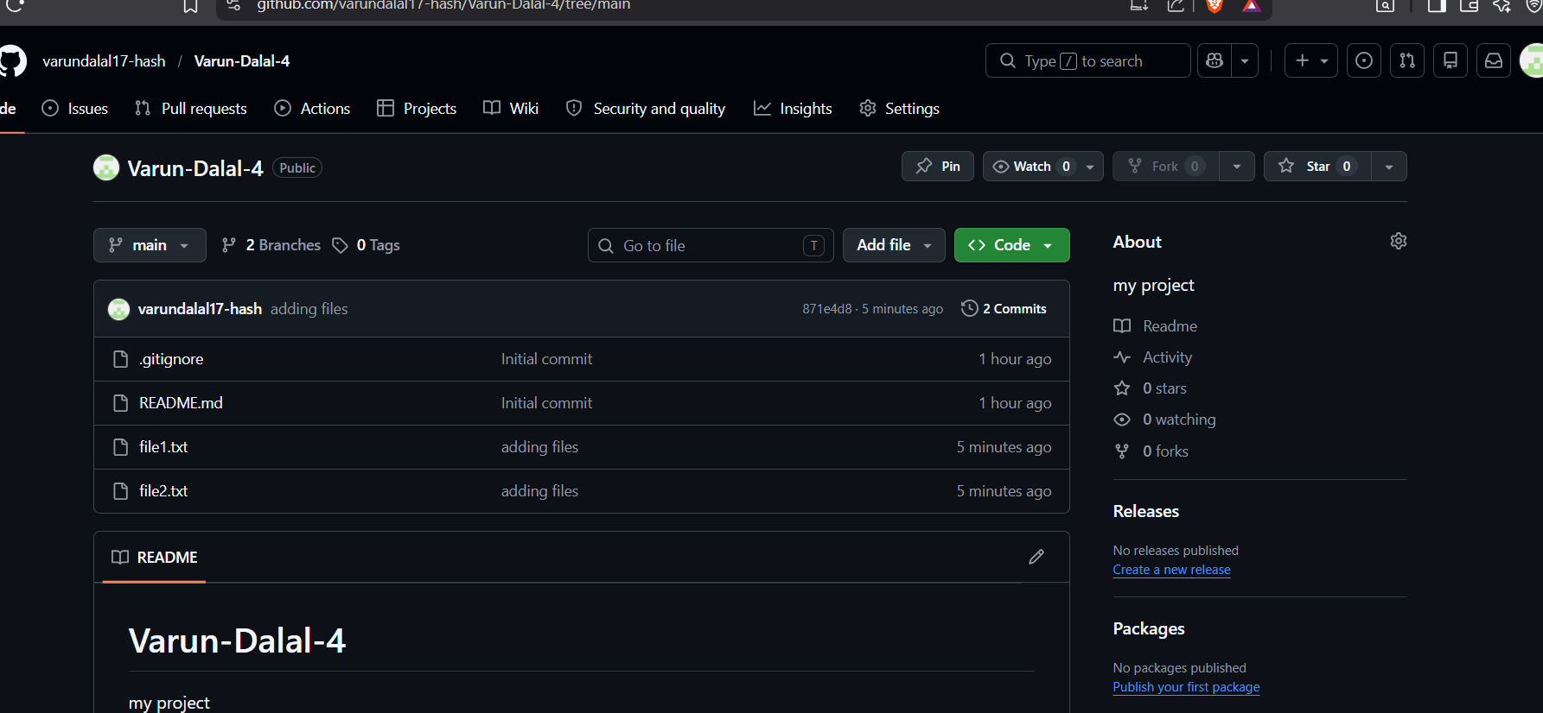

6. Create a branch in local and create a sample file and push to central.
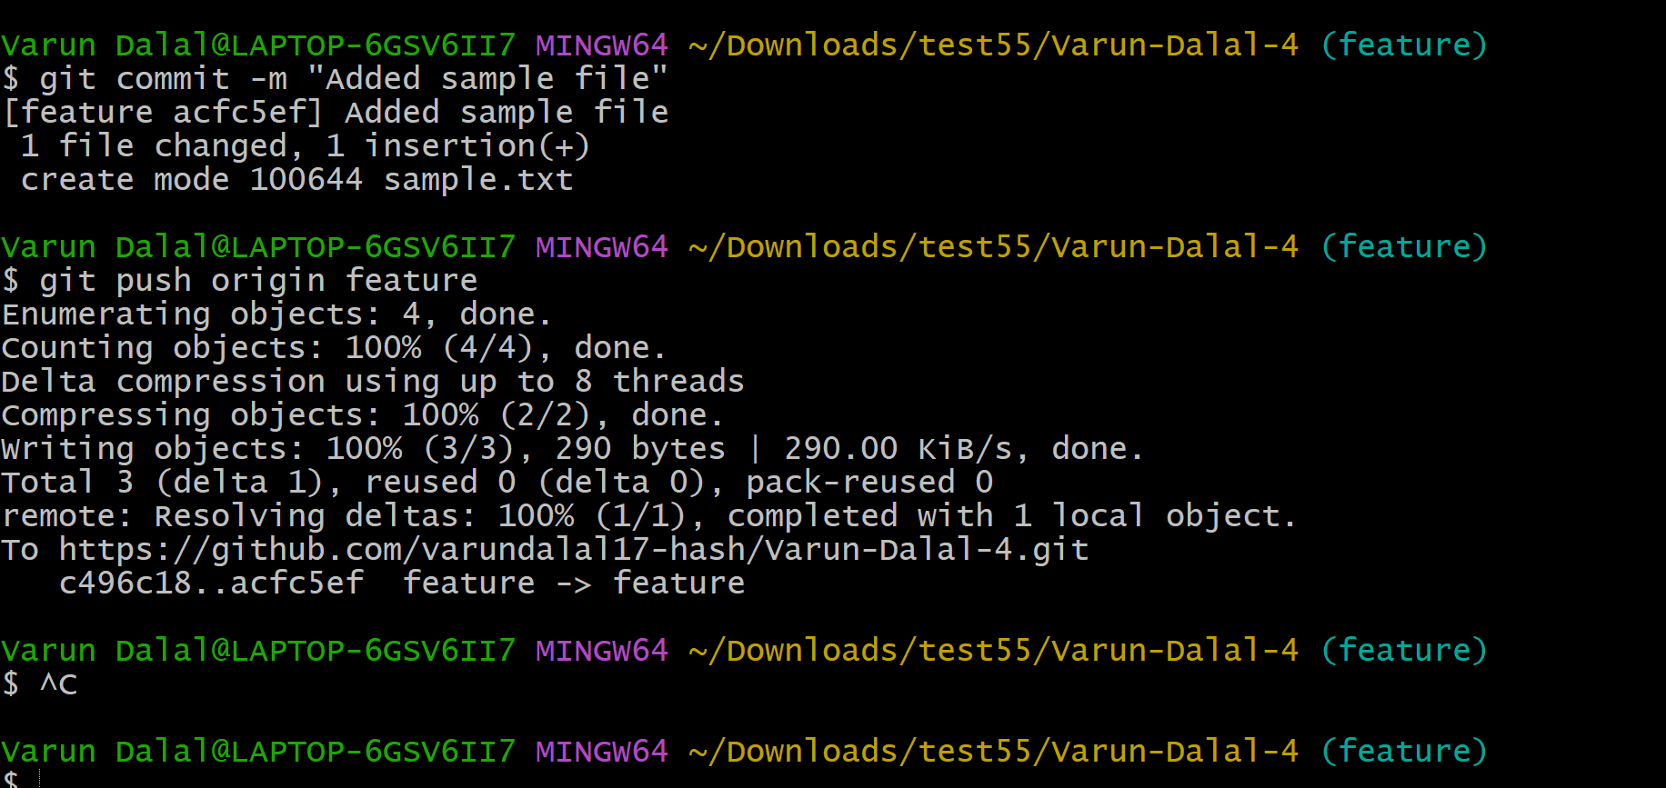

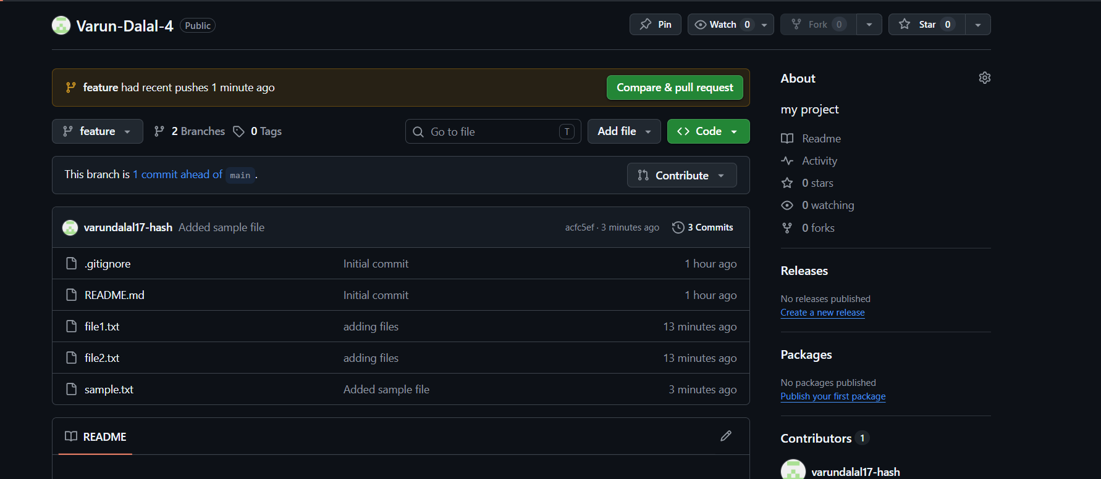

7. Create a branch in git hub and clone that to local
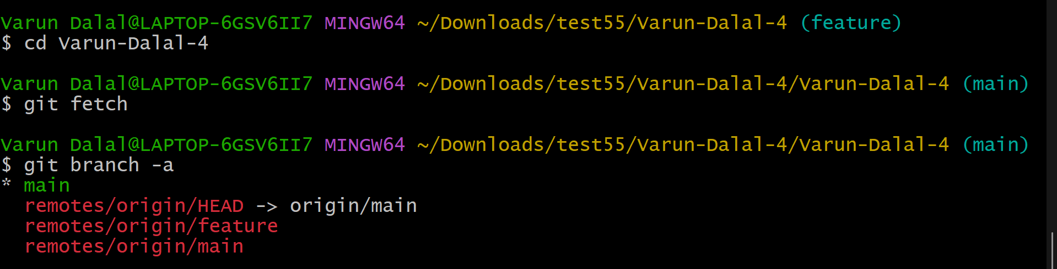

8. Merge the created branch with master in git local
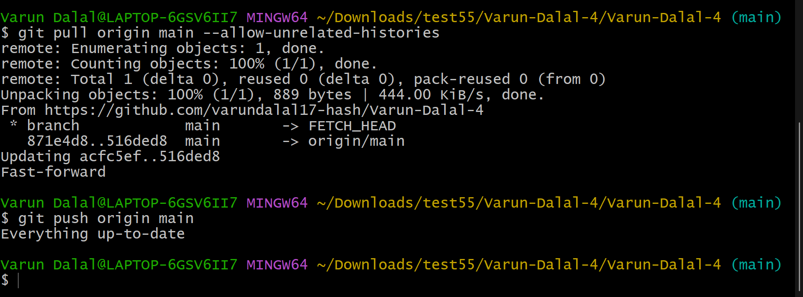

9. Merge the created branch with master in github by sending a pull request. 

10. Create a file in local and send that to branch in github
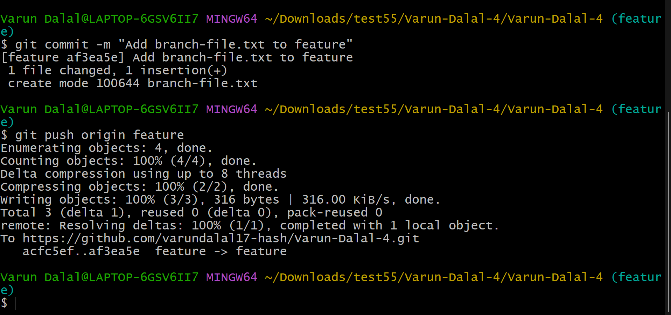

11. Clone only a branch from github to local. 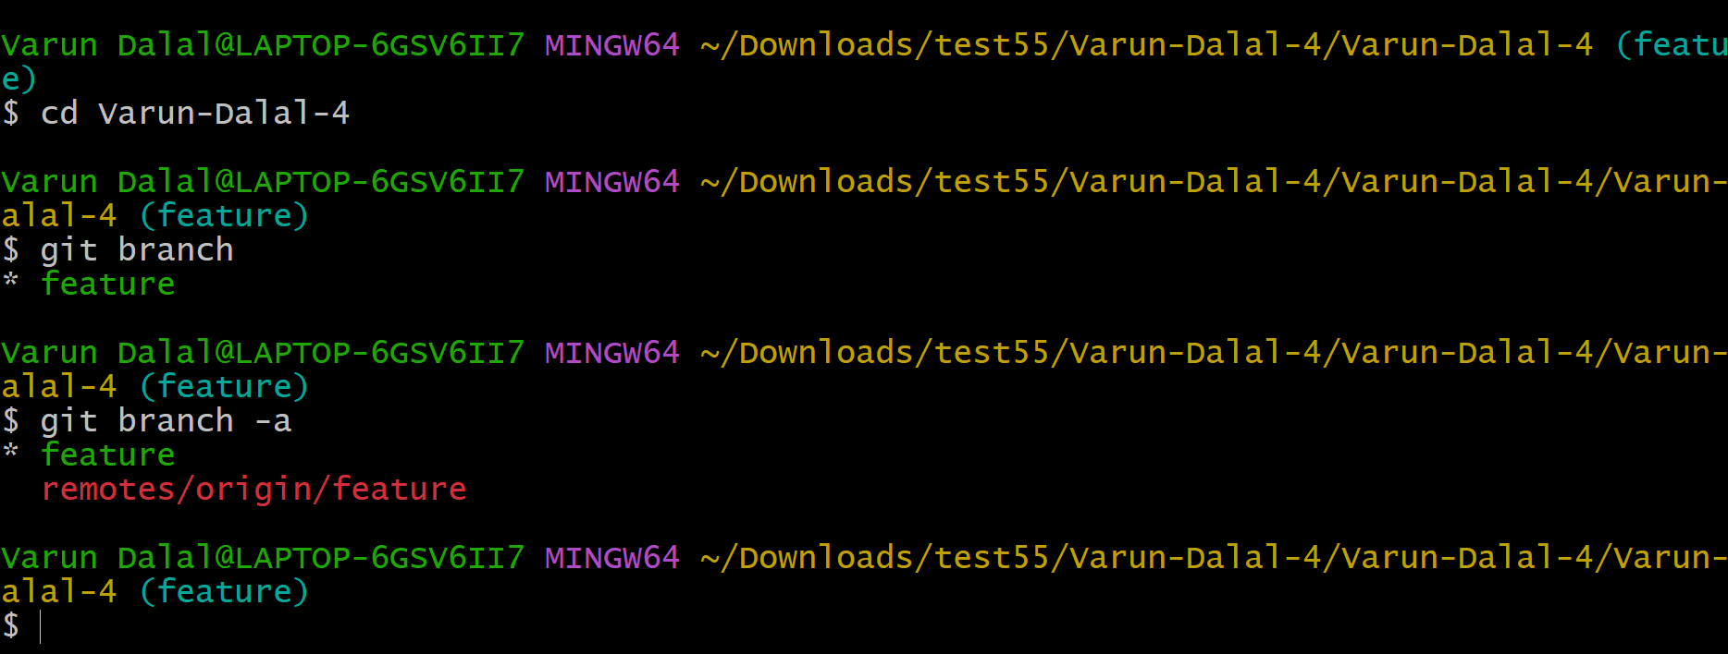

12. Create a file with all passwords and make that untrackable with git.
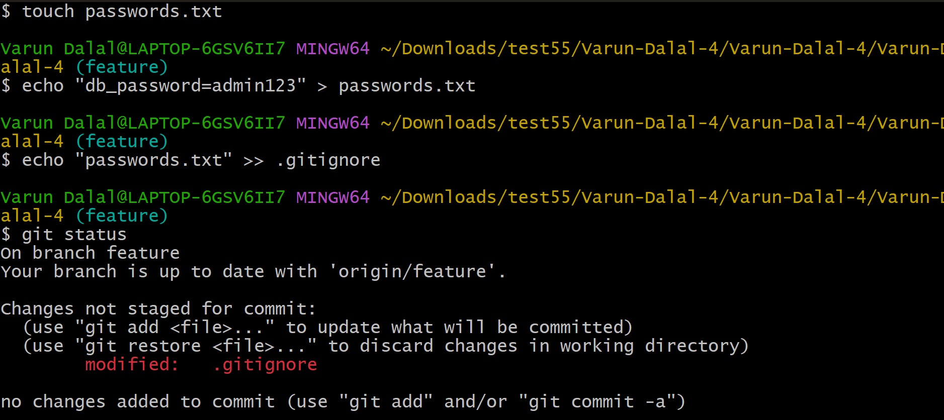

13. Make a commit and make that commit reset without savings changes
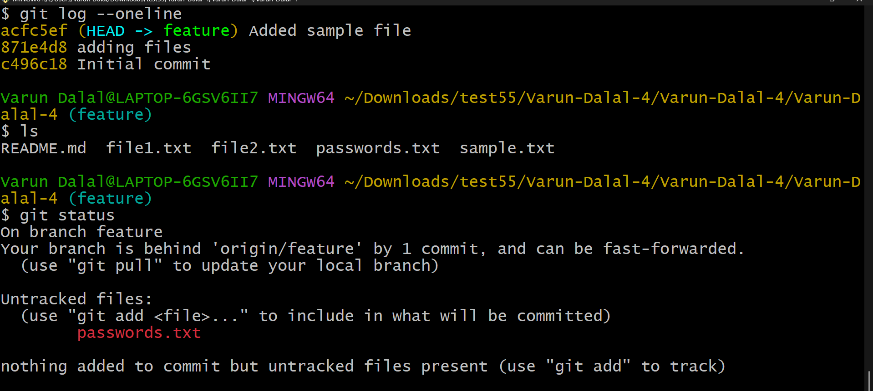
14. Revert a commited commit to the older version.
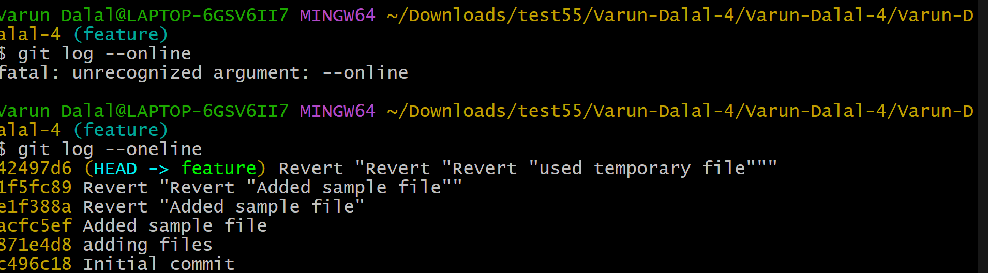

15. Push a file to stash without savings the changes and work on another file
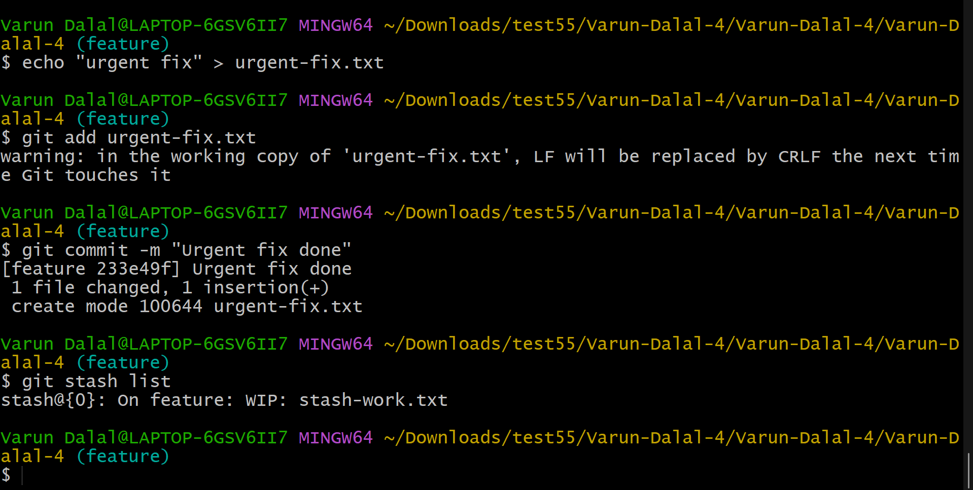

16. Undo the stash file and start working on that again.
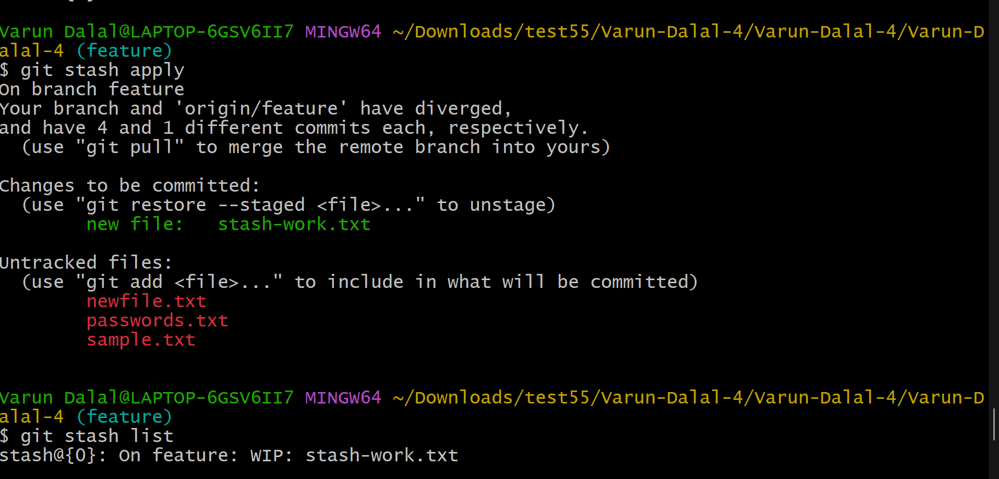

17. Generate a ssh-keygen and configure into github
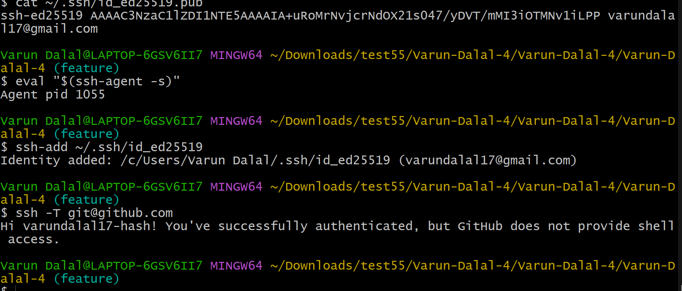

18. Configure webhooks to github
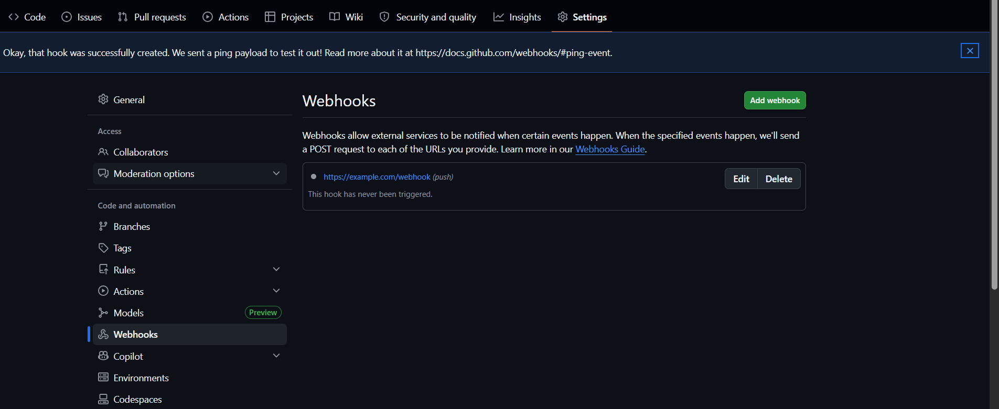

19. Basic understanding of .git file
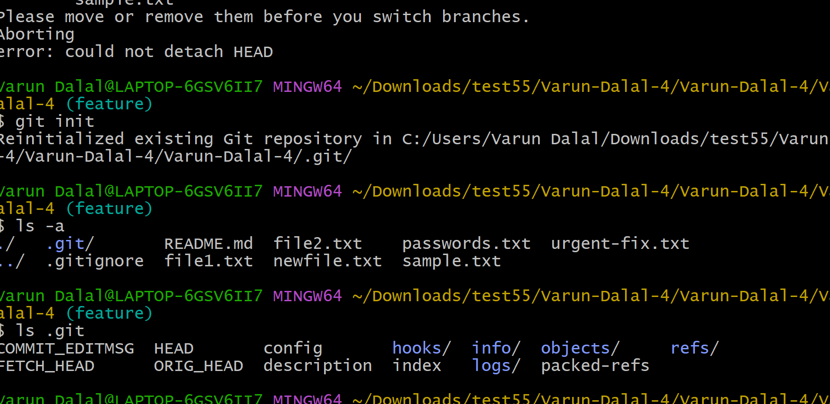
20. Check all the logs of git
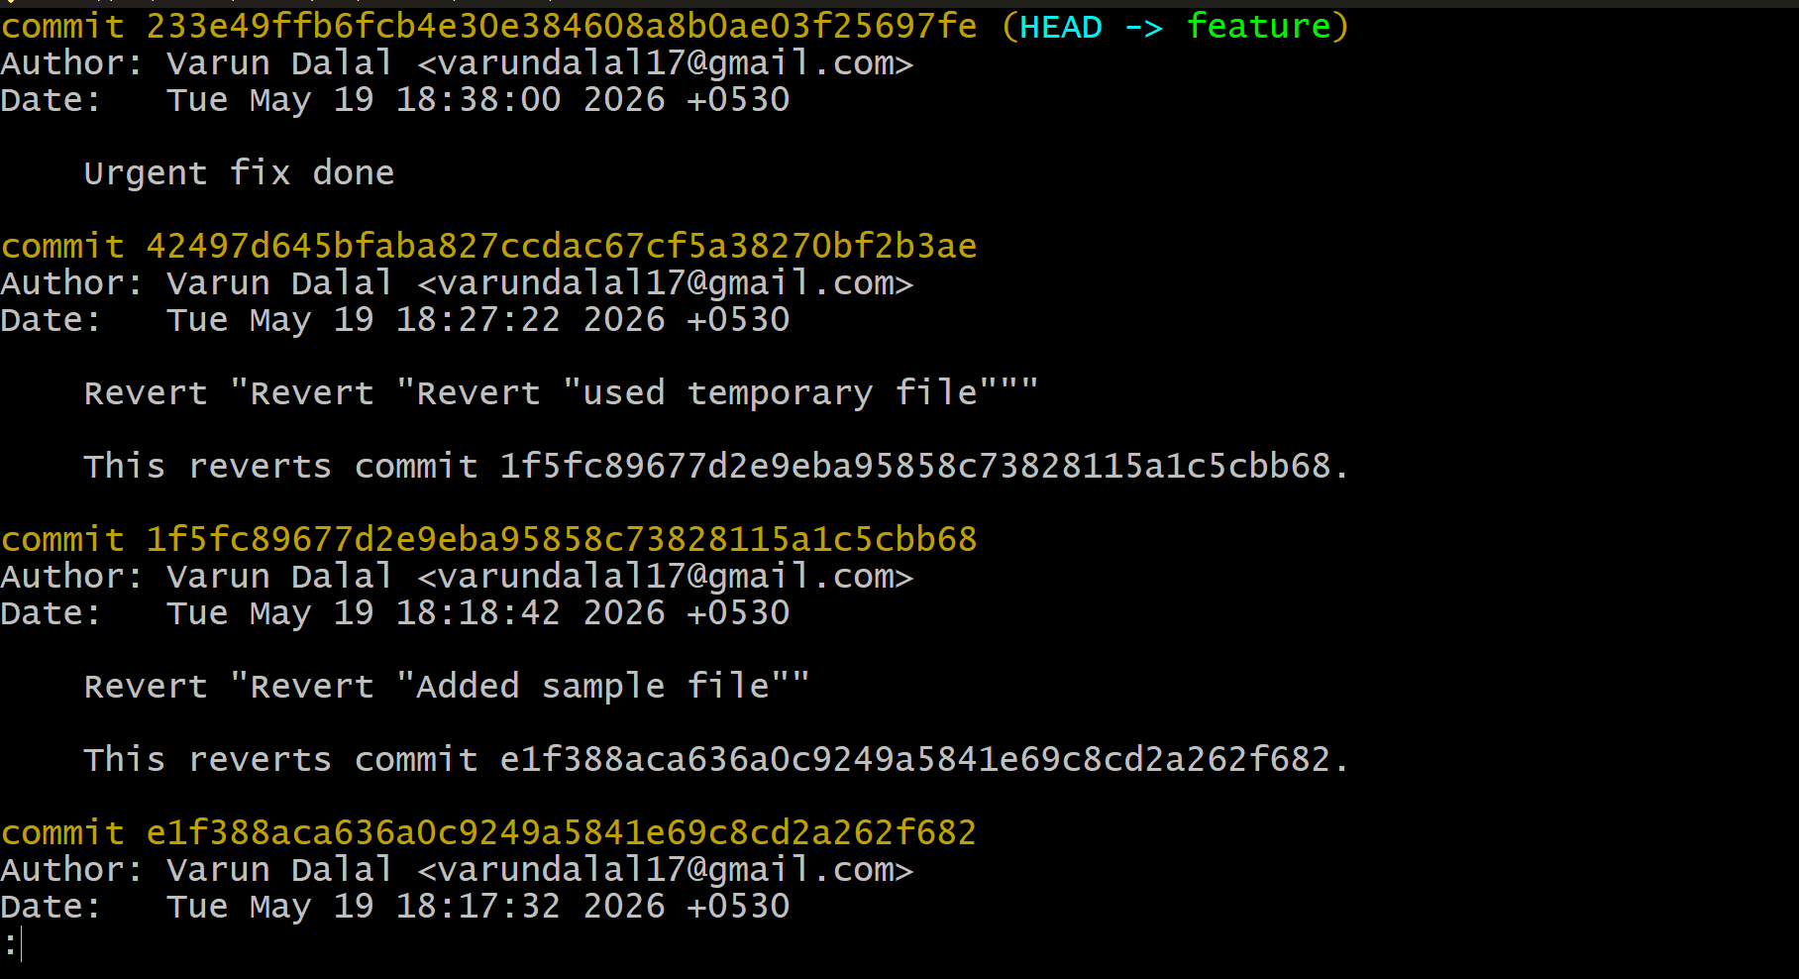
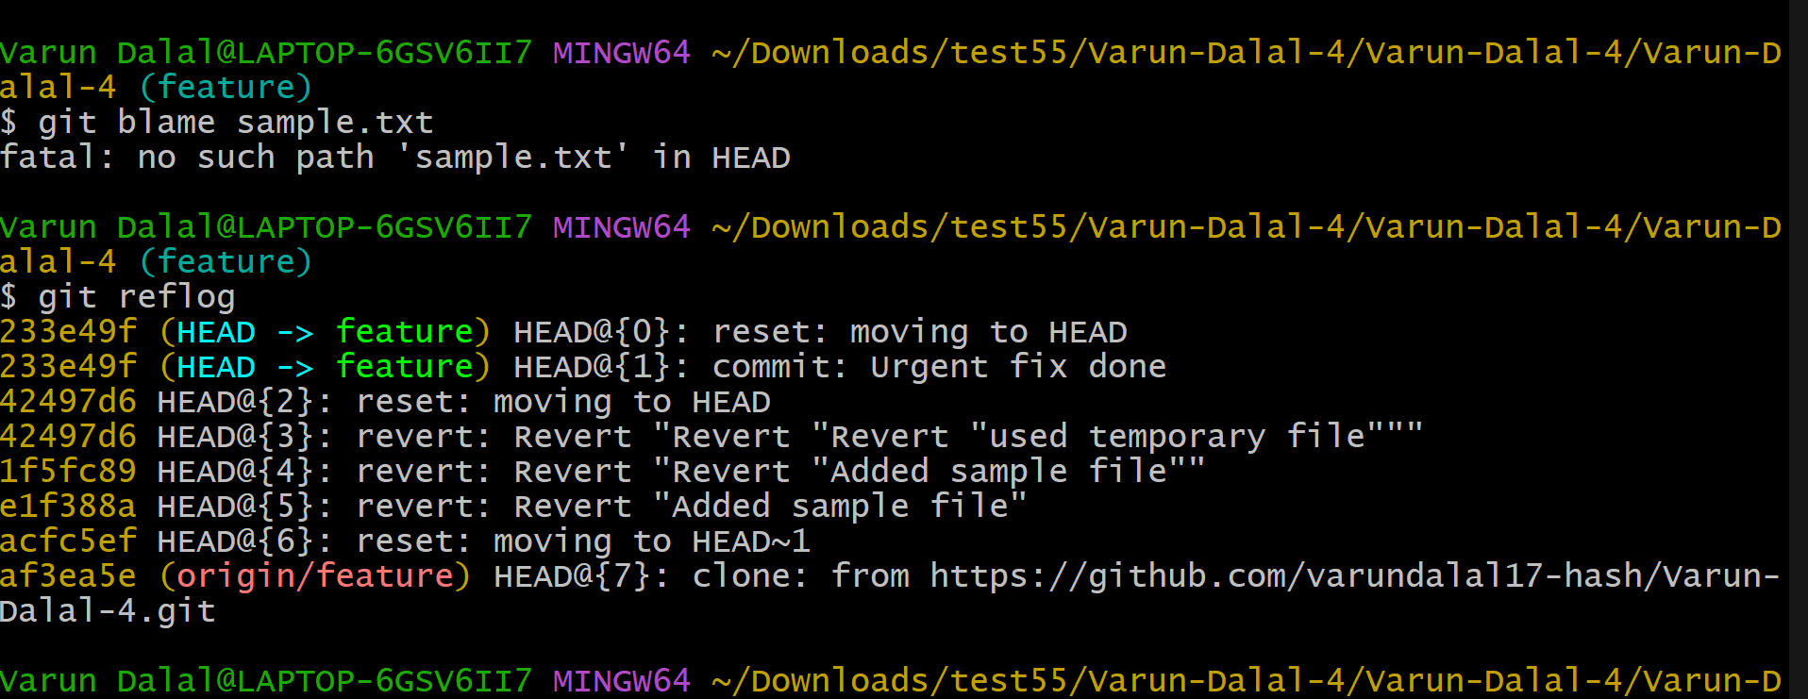

21. Rename the commit message 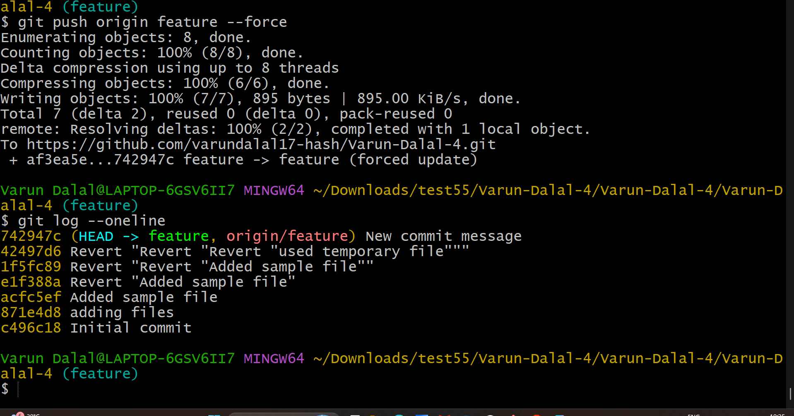

22. Merge multiple commits into single commit. 